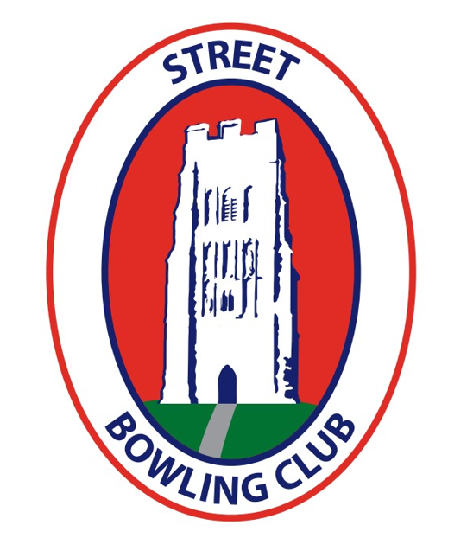

OPEN FOURS TOURNAMENT
Sunday 10th August 2025

Dear Fellow Bowler,

I am writing to invite you to our annual Open Fours Tournament being held this year on Sunday 10th August 2025. We very much hope that you will be able to join us on this occasion on a first come first served basis. The first games will commence promptly at 9.30 am or 10.30 am, TEAMS WILL PLAY 4 GAMES comprising of a maximum 1 hour or 10 ends. The prizes will be as follows:-
1st Place £100 2nd Place £80 3rd Place £60 4th Place £40
The entry fee is £40 per team (to be included with entry form) which includes tea or coffee on arrival, morning tea and biscuits, lunch and afternoon refreshments including some delicious homemade cakes. Non-playing visitors can be catered for at £5 per head to include all of the above. Please inform us if you or your team require any dietary requirement on the form below.
Please note entry fees are non-refundable if cancellation notice is given less than 48 hours prior to the tournament date.
If you would like a priority booking please return the form and either cash, cheque or you can now pay by BACS – Account number (51087383) sort code (60-21-01) Account name: Street Bowling Club
(Email address – neilkunc1984@gmail.com) by the 31st May with all other entries closing on 8th June 2025.
…………………………………………………………………………………………..

STREET BOWLING CLUB OPEN FOURS TOURNAMENT
Sunday 10th August 2025
ENTRY FORM

Name (captain)……………………………………………………..

Address…………………………………………………………………………………………………

…………………………………………...………………………………………………………………

Club Name……………………………………………………………..

Contact Telephone Number…………………………………………

Email Address…………………………………………………………

Dietary Requirements…………………………………………………………….

Please select the amount of each food offering you require

Cheese………………… Ham…………………………

please tick a box below with your payment option, so we can check it has been received sucessfully. All other payments can be sent to neil kunc 3 churchill road, wells, somerset, ba5 3hz

BACS Payment Cheque cash

